HANDS-ON LAB
Building an Enterprise Multi-Agent AI Service Desk
Python | FastAPI | Local Qwen AI Model | Multi-Agent Orchestration
Prepared by: Shruti Sinha
AI/ML Architect | Ex AWS | Ex IBM | Ex IIM
Project: Corporate-AI — Enterprise AI Service Desk

Steps of Execution
This lab walks through the design and execution of a multi-agent enterprise IT service desk, built with Python, a local Qwen AI model, and FastAPI. The following steps summarize the execution flow covered in this document:
- Review the lab objectives and business scenario for the Enterprise AI Service Desk.
- Set up the project folder structure and install the required Python packages (transformers, torch, fastapi, uvicorn).
- Build the Multi-Agent Python layer (Corporate_user_helpdesk.py) — the generic AI function, Orchestrator Agent, specialist agents, short-term memory, and Resolution Agent.
- Run and test the Multi-Agent system directly from the terminal, and observe the Orchestrator's routing decision, specialist findings, and final resolution.
- Build the FastAPI backend (app.py) that exposes the /api/solve endpoint.
- Build the web front end (index.html, style.css, script.js) that visualizes the agent workflow.
- Start the FastAPI application with Uvicorn and open the Enterprise AI Service Desk dashboard in a browser.
- Submit sample IT requests through the UI and verify the full multi-agent workflow end to end.

Lab Overview
In this lab, you will build a simple Enterprise AI Service Desk using Python and a local Qwen AI model.
The system will accept an employee's IT problem and use multiple specialized AI agents to investigate the problem.
You will build the following flow:
Employee Request
↓
Orchestrator Agent
↓
┌─────┼────────┐
↓ ↓ ↓
Identity Network Endpoint
Agent Agent Agent
└─────┼────────┘
↓
Short-Term Memory
↓
Resolution Agent
↓
Final Resolution

The original Python implementation demonstrates the same core concepts: AI Agent, Orchestrator Agent, specialist agents, context passing, short-term memory, and a Resolution Agent.

1. Learning Objectives
By the end of this lab, you will be able to:
- Understand the basic architecture of a Multi-Agent System
- Create an Orchestrator Agent
- Create specialist agents
- Pass context between agents
- Maintain short-term memory
- Create a Resolution Agent
- Expose the AI system through a FastAPI backend
- Connect a web UI to the Python AI backend
- Visualize how agents collaborate

2. Business Scenario
Imagine that an employee contacts the corporate IT Service Desk:
"I cannot connect to the company VPN. It was working yesterday but today it keeps failing."

Instead of sending the problem to one general-purpose AI agent, our system uses specialized agents.

Agents
Agent | Responsibility
Orchestrator Agent | Decides which specialists should investigate
Identity Agent | Account, password, MFA and access
Network Agent | VPN, Wi-Fi, DNS and connectivity
Endpoint Agent | Laptop, VPN client, certificate and configuration
Resolution Agent | Combines findings and creates the final answer

3. Architecture
EMPLOYEE
│
▼
┌────────────────┐
│ ORCHESTRATOR │
│ AGENT │
└────────┬────────┘
│
┌────────────┼────────────┐
▼ ▼ ▼
Identity Network Endpoint
Agent Agent Agent
│ │ │
└────────────┼────────────┘
▼
SHORT-TERM
MEMORY
│
▼
RESOLUTION
AGENT
│
▼
FINAL ANSWER

4. Prerequisites
Make sure Python is installed. Verify:
python --version

Recommended: Python 3.10+
You will also need:
- Python
- VS Code or another Python IDE
- Internet access for the initial model download
- Sufficient disk space for the Qwen model

5. Create the Project
Create a folder:
enterprise-ai-helpdesk

Inside the folder, create:
enterprise-ai-helpdesk/
│
├── Corporate_user_helpdesk.py
├── app.py
│
└── static/
├── index.html
├── style.css
└── script.js

6. Install Python Packages
Open a terminal inside the project folder.
Install the AI dependencies:
pip install transformers torch

Install FastAPI:
pip install fastapi uvicorn

You can also install everything together:
pip install transformers torch fastapi uvicorn

Verify FastAPI:
python -c "import fastapi; print(fastapi.__version__)"

7. Create the AI Agent Layer
Create: Corporate_user_helpdesk.py
The Python file contains:
call_ai()
↓
orchestrator()
↓
┌────┼────┐
↓ ↓ ↓
Identity Network Endpoint
↓
resolution_agent()

The system uses the local model:
Qwen/Qwen2.5-0.5B-Instruct

The model is loaded using the Transformers pipeline.

8. Understand the Generic AI Function
The call_ai() function is the common AI interface used by all agents.
Conceptually:
System Instruction
+
User Context
↓
Qwen Model
↓
AI Response

All agents use the same underlying model.
What makes the agents different is their role and instruction. For example:
Orchestrator
→ Decide which agent should investigate

Identity Agent
→ Investigate identity problems

Network Agent
→ Investigate network problems

Endpoint Agent
→ Investigate device problems

Resolution Agent
→ Combine findings

This is an important Multi-Agent concept:
Same AI model + different roles = different specialized agents.

9. Understand the Orchestrator Agent
The Orchestrator does not solve the employee's problem. Its job is:
"Which specialist agents should investigate?"

For example:
Employee:
I cannot connect to VPN.

↓

Orchestrator

↓

NETWORK
+
ENDPOINT

The Orchestrator can select:
IDENTITY
NETWORK
ENDPOINT

depending on the request.
The uploaded implementation defines the specialist areas and asks the Orchestrator to return the required agent names.

10. Understand the Specialist Agents

Identity Agent
Responsible for:
- Account
- Password
- MFA
- Access
- Permissions

Network Agent
Responsible for:
- VPN
- Wi-Fi
- Internet
- DNS
- Firewall
- Network connectivity

Endpoint Agent
Responsible for:
- Laptop
- VPN Client
- Software
- Device Configuration
- Certificate
- Local Firewall
The specialist agents receive the incident context and produce a short finding.

11. Understand Context Passing
This is one of the most important concepts in the lab.
The employee's original request is passed to the specialist agents. Example:
Employee Request:
"I cannot connect to VPN."

↓

Orchestrator Decision:
NETWORK + ENDPOINT

↓

Shared Context

↓

Network Agent
Endpoint Agent

The agents don't receive completely isolated information. They receive the relevant context.

12. Understand Short-Term Memory
The system maintains information about the current incident. The memory contains:
Employee Request
+
Orchestrator Decision
+
Agent Findings

For example:
SHORT-TERM MEMORY

Employee Request:
VPN connection failing

Orchestrator Decision:
NETWORK, ENDPOINT

Agent Findings:

NETWORK:
VPN service appears operational

ENDPOINT:
VPN client/certificate may require attention

The original implementation stores the employee request, orchestrator decision and specialist findings in a short-term memory structure.

13. Understand the Resolution Agent
The Resolution Agent receives the accumulated information.
Employee Request
+
Orchestrator Decision
+
Specialist Findings
↓
Resolution Agent
↓
Final Answer

It produces:
- Most likely root cause
- What the employee should check
- Recommended next step
This is the final stage of the Multi-Agent workflow.

14. Test the AI System in Terminal
Before building the UI, test the Multi-Agent system directly. Run:
python Corporate_user_helpdesk.py

You should see:
ENTERPRISE AI SERVICE DESK
MULTI-AGENT DEMO

Enter the employee IT problem.
Type END when finished.

Enter:
I cannot connect to the company VPN.
It was working yesterday but today it keeps failing.
I have an important client meeting in 30 minutes.
END

15. Observe the Orchestrator
You should see something similar to:
ORCHESTRATOR AGENT

Selected specialist agents:

→ NETWORK
→ ENDPOINT

The exact result may vary because the decision is generated by the AI model.

16. Observe the Specialist Agents
The selected agents will investigate. For example:
SPECIALIST AGENTS

→ Running NETWORK Agent...

Network finding:
VPN service appears operational...

→ Running ENDPOINT Agent...

Endpoint finding:
Check VPN client configuration or certificate...

17. Observe Short-Term Memory
The system then displays:
CURRENT SHORT-TERM MEMORY

Employee Request:
I cannot connect to the company VPN...

Orchestrator Decision:
['NETWORK', 'ENDPOINT']

Specialist Findings:

[NETWORK]
...

[ENDPOINT]
...

Pause here during the class. Explain:
"This is what the system currently knows about this incident."

18. Observe the Resolution Agent
The Resolution Agent receives the accumulated memory. You should see:
RESOLUTION AGENT

followed by a final answer. For example:
Most likely root cause:
The problem appears to be related to the endpoint VPN configuration.

What to check:
Verify the VPN client and device certificate.

Recommended next step:
Restart the VPN client and verify the certificate.

The exact response will depend on the model.
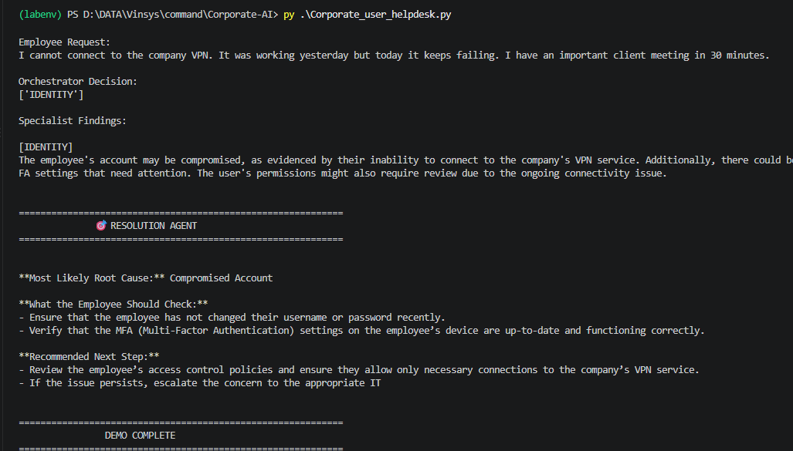
Figure 1: Terminal demo showing the Orchestrator decision, specialist findings, and the Resolution Agent's final output

19. Convert the AI System into a Web Application
Now we will separate the application into two layers.
WEB UI
│
▼
FastAPI
│
▼
Multi-Agent Python
│
▼
Qwen AI

The browser should not directly call the AI model. Instead:
Browser
↓
HTTP Request
↓
FastAPI
↓
Python Agent Layer
↓
AI Model

20. Create the FastAPI Backend
Create: app.py
The backend exposes:
POST /api/solve

The browser sends:
{
"problem": "I cannot connect to the company VPN"
}

FastAPI sends the request to the Multi-Agent system. The backend returns:
{
"selected_agents": [
"NETWORK",
"ENDPOINT"
],
"findings": {
"NETWORK": "...",
"ENDPOINT": "..."
},
"final_answer": "..."
}

21. Create the Frontend Folder
Create: static/
Inside it create:
static/
│
├── index.html
├── style.css
└── script.js

22. Create index.html
The UI should contain:
Enterprise AI Service Desk

[ Describe your IT issue ]

[ Submit ]

Orchestrator Agent
↓

Identity Network Endpoint
Agent Agent Agent

↓

Resolution
Agent

Activity Feed Short-Term Memory

Employee Request Request
Agent Activity Decision
Agent Status Findings

The important classroom feature is that students can see the agents working.

23. Create style.css
The CSS provides:
- Agent cards
- Agent icons
- Status badges
- Workflow layout
- Activity feed
- Memory panel
- Resolution panel
- Running animation
For example:
Identity Agent
RUNNING

Network Agent
RUNNING

Endpoint Agent
WAITING

24. Create script.js
JavaScript sends the employee's request to FastAPI. The important call is:
fetch("/api/solve", {
method: "POST",

headers: {
"Content-Type": "application/json"
},

body: JSON.stringify({
problem: problem
})
});

The browser receives the JSON response and updates the agent cards.
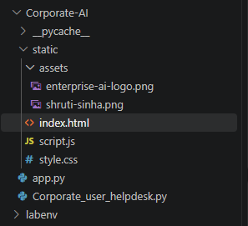
Figure 2: Final Corporate-AI project structure — app.py, Corporate_user_helpdesk.py, and the static front-end folder

25. Start the Web Application
From the project directory run:
uvicorn app:app --reload

You should see:
Uvicorn running on
http://127.0.0.1:8000

Open:
http://127.0.0.1:8000
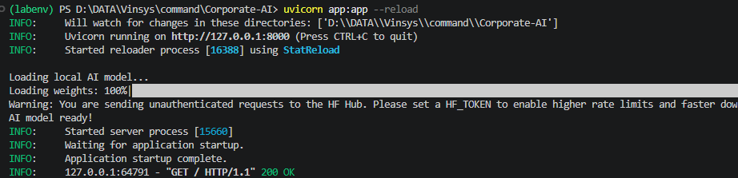
Figure 3: Uvicorn server startup log — model weights loaded to 100% and application startup complete

26. Test Through the UI
Enter:
I cannot connect to the company VPN.
It was working yesterday but today it keeps failing.

Click: SUBMIT
The UI should show:
Orchestrator Agent
ACTIVE

↓

Identity Agent
Network Agent
Endpoint Agent

↓

Short-Term Memory

↓

Resolution Agent

↓

Final Resolution
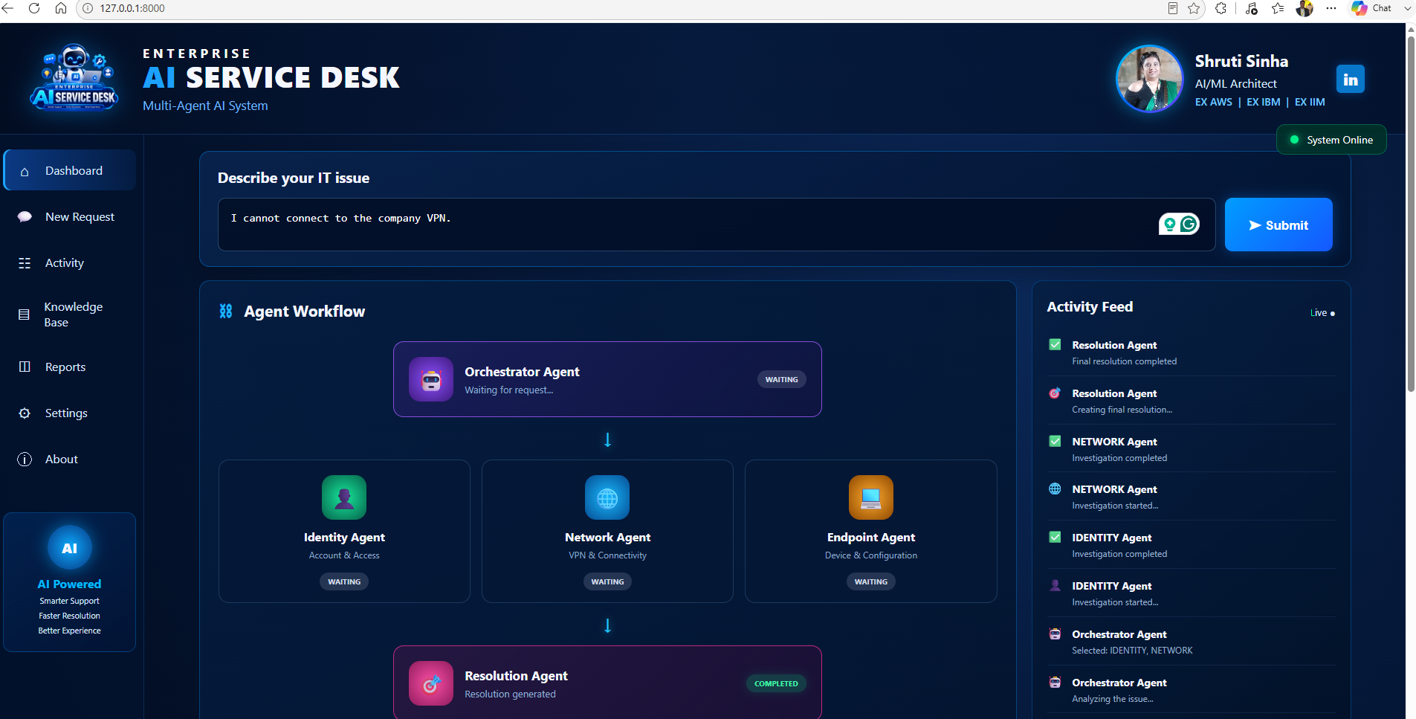
Figure 4: Enterprise AI Service Desk dashboard showing the completed agent workflow and activity feed

27. Classroom Demonstration
Now demonstrate three different incidents.

Test Case 1 — VPN
Enter:
I cannot connect to the company VPN.

Expected concept:
Orchestrator
↓
Network + Endpoint

Test Case 2 — Password
Enter:
My corporate password is not working and I cannot log in.

Expected concept:
Orchestrator
↓
Identity

Test Case 3 — Laptop
Enter:
My laptop connects to Wi-Fi but the VPN client is not working.

Expected concept:
Orchestrator
↓
Network + Endpoint

The exact agent selection is AI-generated, so treat these as expected routing concepts rather than guaranteed outputs.

28. What Students Should Observe
Ask students:

Question 1
Who decides which agent should work?
Answer: Orchestrator Agent

Question 2
Does the Orchestrator solve the problem?
Answer: No. It decides which specialist agents should investigate.

Question 3
Why have different agents?
Answer: Each agent has specialized responsibility.

Question 4
How do agents share information?
Answer: Through shared context and short-term memory.

Question 5
Who creates the final answer?
Answer: Resolution Agent.

29. The Key Concept
Write this on the whiteboard:
ONE AI MODEL
+
DIFFERENT ROLES
+
SPECIALIZED AGENTS
+
SHARED CONTEXT
+
ORCHESTRATION
=
MULTI-AGENT SYSTEM

30. Final Architecture
At the end of the lab, students should understand:
┌───────────────────────────┐
│ WEB UI │
│ │
│ Employee enters IT problem │
└─────────────┬─────────────┘
│
▼
┌───────────────────────────┐
│ FASTAPI │
│ │
│ /api/solve │
└─────────────┬─────────────┘
│
▼
┌───────────────────────────┐
│ MULTI-AGENT SYSTEM │
│ │
│ Orchestrator │
│ │ │
│ ┌────────┼────────┐ │
│ ▼ ▼ ▼ │
│ Identity Network Endpoint │
│ │ │ │ │
│ └────────┼────────┘ │
│ ▼ │
│ Short-Term Memory │
│ │ │
│ ▼ │
│ Resolution │
└─────────────┬─────────────┘
│
▼
Final Resolution

31. Lab Completion Checklist
☐ Install Python dependencies
☐ Create project folder
☐ Create Corporate_user_helpdesk.py
☐ Run the terminal Multi-Agent demo
☐ Test the Orchestrator
☐ Test specialist agents
☐ Observe short-term memory
☐ Observe Resolution Agent
☐ Create FastAPI backend
☐ Create static folder
☐ Create index.html
☐ Create style.css
☐ Create script.js
☐ Start FastAPI
☐ Open the web UI
☐ Submit an IT problem
☐ Observe the agent workflow
☐ Test multiple IT scenarios

32. Key Takeaway
The goal of this lab is not simply to build a chatbot.
The goal is to understand how an enterprise problem can be divided among specialized AI agents.
User Problem
↓
Orchestrator
↓
Specialists
↓
Shared Context
↓
Resolution

This is the foundation for building larger Agentic AI systems with tools, RAG, APIs, persistent memory, guardrails, human approval, and enterprise services.

